ANNUAL REPORT
2011

(IMANI REHABILITATION AGENCY)
INTRODUCTION

I
mani rehabilitation agency is a nonprofit organization with its headquarters in kayole slums of Nairobi. The organization was founded in 1992 and contributes to the society by providing a stepping stone for abandoned, neglected, lost, orphaned and abused children. Despite the harsh realities we face in our Kenyan society, Imani which means faith in Kiswahili, works towards the vision of creating a society which all children will be able to live a dignified existence while growing up with equal and access to future opportunities in life. To achieve the latter we focus on intensive parental care, good medical care and education, to rehabilitate the children before we reintegrate them back to the society having been equipped with ample life management skills.

……Six Programmes

Imani A Kayole (Soweto)
The mother centre situated in Kayole -Soweto .This is also where the older children undergoing their primary and secondary education reside, their ages range from six to eighteen years.

Imani B Kayole (Matopeni)
The center caters for children of ages 2 to 10 years. A small animal farm is found in Imani ‘B’.

Imani babies unit
Takes care of abandoned babies from a day old to 2 years and gives them care, protection and primary health before releasing them for adoption or foster care.

Imani Malindi
Is a rescue center for orphans and vulnerable children located in the costal part of Kenya. It is also a holiday place for Children of the entire Imani family.

Imani Ngong’special unit’
Caters for the needs of physically and sexually abused children and children whose parents have been imprisoned.

After Imani projects (Kibera &Kassarani)
Project for the young persons (boys and girls) respectively who have not known families at any level and therefore when they attain 18 years and are rehabilitated they stay there as they pursue their education

To optimally intervene on the five categories of children we work for we have six programmes which cater for their specific needs.

HIGHLIGHTS OF THE YEAR

This marks end of the year 2011. Although this would just be a fraction of the nineteen years that we have been working with children, we indeed felt the sweetness of the fruits of our toil. We may not have attained our actualization yet, but by welcoming on board two of the children who grew up in Imani take up managerial positions was a moment of pride to the entire fraternity.
Indeed, this has been a time for us to look back and focus more on the future so as to reinforce the services we give to children in need of care and protection.
Events graced our year where got to hold an annual prize giving day for the children, an annual thanksgiving with the community around us for their support and a wedding planning event for two of our children who shall be getting married in the year 2012.
We also shared our bundles of joy with other parents on the 15th of October when we officially handed over nine of our children to their adoptive parents at an emotional ceremony in Imani B.
We being laid on a Christian foundation, celebrated Christmas in Imani B where we enjoyed a good time with visiting friends.

PROGRAMME ACTIVITIES

1. Parental care and guidance

1.1Motivation

One of our spearheads for the year was to ensure that our children felt safe, secure and appreciated. We embraced every talent identified within our children and gave them an arena to showcase their talents within the framework of a Christian approach. During the April, August and December holidays, we engaged our children in activities that natured their personal development. Such as, Painting, taking care of the babies, Nursing, Cooking all which were done under the guardianship of an adult professional.
In a bid to encourage positive behavior and reward good efforts by our children, we organized trips such as the trip to Mara in August and the flight trip to Mombasa which was sponsored by Kenya airways.

1.2Child participation

In line with the children’s act, we acknowledge that children have the full right to take part in matters that concern them. On the 25th of August 2011 our children made their independent behavioral management system. This system would help to resolve
Matters between them and also to present their ideas to their caretakers. It included four judges, seven lawyers and a children’s chairman. We also participated in events such as day of the African child among other events in honor of orphans and vulnerable children.

1.3counselling and psychosocial help

In order to optimize on the rehabilitative component of working with our children, we welcomed on board a child counselor who has been undertaking

Sessions with the children either at a personal level or through group sessions. Most of the group sessions were conducted during the hikes that took part at least twice in every quarter.

2. Healthcare

Battling with diseases remained a challenge to us partly due to the reason that most of the children brought to us are rescued from harsh environments and therefore have a weak immune system and also due to the cold climatic conditions.
However, continued to provide quality healthcare to our beneficiaries. Most the cases were managed by our in-house nurse and part-time doctor. Some of the cases that needed more specialized facilities were referred to other hospitals for extensive consultation and research. Most of the referrals were those of newly admitted babies who had been rescued from conditions which had put their health at stake. We also faced a challenge at our Ngong home where there are no hospitals around the area. Some of the children who needed medical consultation had to taken to our Imani A centre for medical assessment.

3. Education

On the onset of the year, we encountered some educational challenges in school performance of our children. In a bid to deal with the shortcomings, in this we appointed an educational social worker who went round all our children’s schools on a weekly basis to monitor their progress and initiate new programmes such as presenting daily record books to the respective teachers that would help better the performance. At end of the year, most of our children sat for the end of term examinations. For two of them this examination would mark the end of their primary education. For the other two, it would be end of secondary education.
Ten of our children graduated from kindergarten and shall be joining primary school in the beginning of the year 2012.
On the 14th of December, at our Imani B home we held an annual prize giving event to award those who had done well in the examination and also in other co-curricular activities.

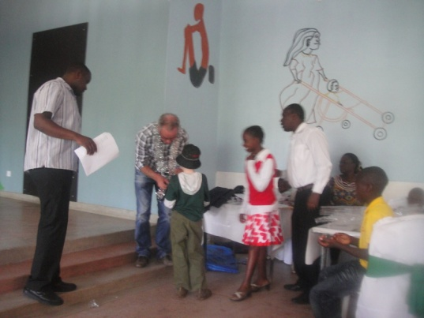
Best of the best

4. WOMEN EMPOWERMENT PROGRAMME

At Imani, our main area of focus is to take care of children in need of care and protection. Sadly, in some instances we receive cases where children are subjected to live in hardships due to the nature of families they are in. It is through the community that we get to educate the general public on the importance of children in the society. We accept as true the slogan that education is power and believe that once people are educated they are able to become self reliant and in return some of the frustrations brought about by economic inadequacy can be minimized.
Every day, Imani receives at least a person from the community being in need of assistance. A higher majority of this number are usually women who present themselves as being needy, desperate or emotionally imbalanced. An encounter with the social worker gives direction on either offering a food basket, referral to a more specialized organization(depending on nature of case)or being enrolled in the empowerment programme.
On voluntary basis we engaged community mothers in child care. These mothers acted as a bridge between us and the community and also
Strengthen the relation that we have with community.
Within the year, we received about 90 members of the community who needed our intervention.32 of them requiring adoption advice, 22 seeking employment and the rest 36 being in need of livelihood support. Out of this number we worked with an average of thirteen women who completed the full term six months training and were either employed as casuals or referred to other agencies for employment.

5. EXIT PROGRAMMES

5.1 Reintegration

Imani serves as a stepping stone for vulnerable children where they get rehabilitated and afterwards reintegrated back to the community. However some children’s cases take time to resolve as the court cases involving them are lengthy and therefore result to the child being under our care until the court appoints a legal guardian for the child. Through tracing and case follow-ups 19 children were placed back with their families to various parts of the country.

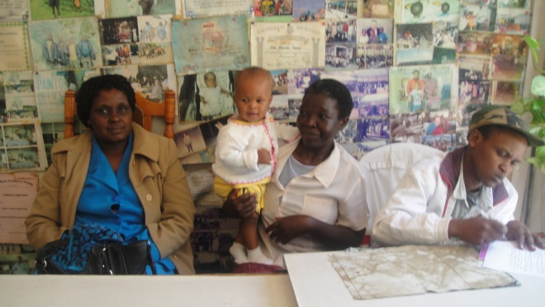

5.2 Adoption

As one of the exit strategies at Imani, this is to take up activities for the best interests of a child, 18 children ranging from seven months to four years were given up for adoption within the year. We continued to lobby for the review of adoption rules in children forums as the rigidity of the laws made the number of adoptions limited.
Imani receives at least 20 adoption applications in every quarter. However, due to the stringent laws that limit the liberty to adopt a child of a choice makes the chances to optimize on placement low.

For instance a section of the rules stipulates that women are only allowed to adopt girls while men can only adopt boys. This went against the preference of many who would wish to adopt a child of a different sex.

5.3 Foster care

We placed 15 children with community members. This was done after we felt that these children were rehabilitated and needed a smaller family unit that would promote their holistic growth. The foster parents were allowed time to

Bond with the children before placement through the district’s children’s office. We also continued to perform follow-ups for the other fifteen children who are also living with foster parents.

6. Organization

6.1 Staff

This year marked the end of our strategic year 2006-2011.An important meeting was held on 25th August a meeting was held at blue post hotel to strategize a plan that would guide the next strategic period. It was equally a good experience for all the departmental heads for team building and strengthening. It took a discursive dimension where the participants tried to reach out for a proper way of ensuring that our service delivery plan was well understood for its realization by the staff members.

Indeed, as the slogan goes ‘If you want to change the world change a child’ we welcomed two managers for our Ngong and Imani A centers. The remarkable fact about our new managers who qualified after extensive interviews was that both of them were old children of Imani. Stephen Soita who had been an engineer took up the managerial responsibility of Imani A and Tabitha Imani previously a merchandise manager being the Manager for the Ngong centre

6.2 Partnerships

One of the aims of Imani is after rehabilitation to work out the best way possible to reintegrate the children back to the community where permanency is definite. Through the facilitation of The Samaritan’s purse international relief two of our social workers from October were trained on the best practices on undertaking reintegration. The programme will see a total of 15 children being reintegrated back to their families in the year 2013.

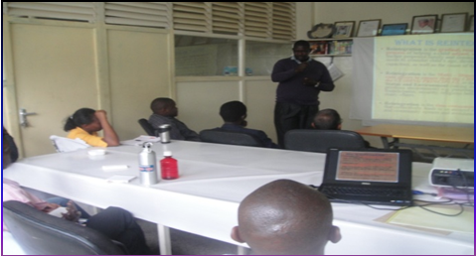
Meeting in session

7. HIGHLIGHTS OF DIFFERENT HOUSES

Imani a
Being the mother centre, most of the administrative activities were undertaken her.Every Monday we conducted an in-house sharing where representatives from the other centers attended.
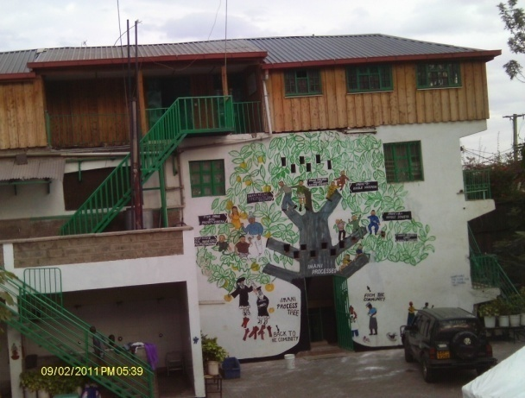

IMANI B
Most of our activities were facilitated at this centre, through the year we held adoption ceremonies, marriage negotiations, annual meetings with partners and finally our charismas celebrations where we all congregated there.

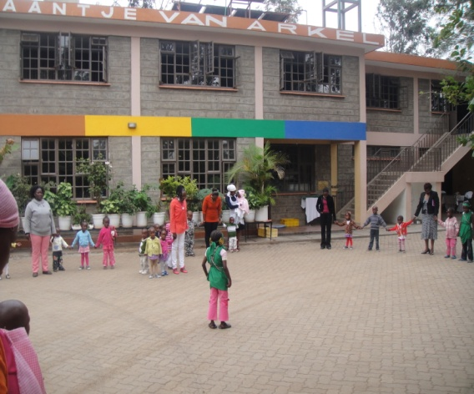

IMANI BABIES UNIT

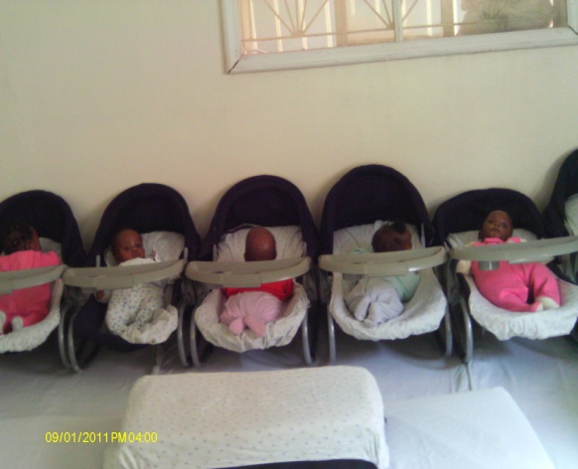
We received an average of six babies every month whom we natured with great joy. Some babies learnt how to walk,and therefore graduated to Imani B as it is our culture.

IMANI MALINDI RESCUE / HOLIDAY PROJECT

We enjoyed a good time in Malindi during the holidays where children from Nairobi got the chance to experience the tropical climate of Malindi which is at the Kenyan cost
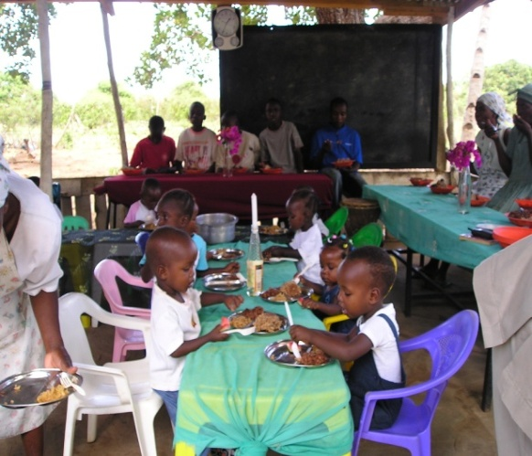

Imani ngong

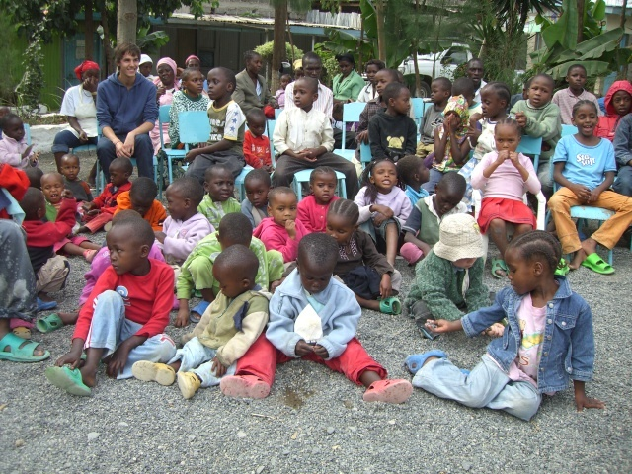

Our livelihood projects in the Centre picked well where our cows, and chickens provided us with plenty and even left surplus for the other centers.

IMANI KIBERA &KASARANI

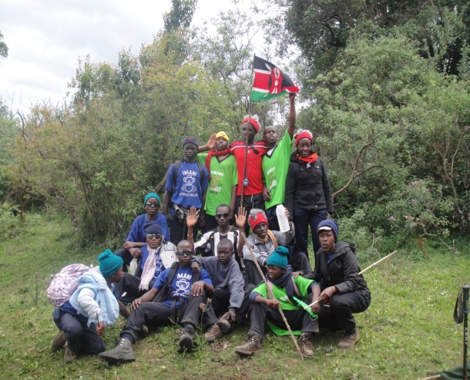
Two of our children joined the teenage houses as they had enrolled to Unversity.One was admitted to pursue medicine and the other Food sciences

8 APPRECIATIONS

We come to the end the of the yet another year. The kind support you have accorded us has made us come this far. We truly feel that with your support we have been able to move closer to achieving our vision: To contribute into a society in which all children will be able to live a dignified existence, with

equal and just opportunities in life. We truly hope that we will walk together through the forthcoming year as we celebrate our twentieth anniversary and reinforce our activities in giving a vulnerable child a better life. Have a prosperous new year.

- John Volken
- Femi
- Foundation Imani
- Quack foundation
- Friends of Imani
- Administrative and support staff

