IMANI REHABILITATION AGENCY
ANNUAL REPORT 2025

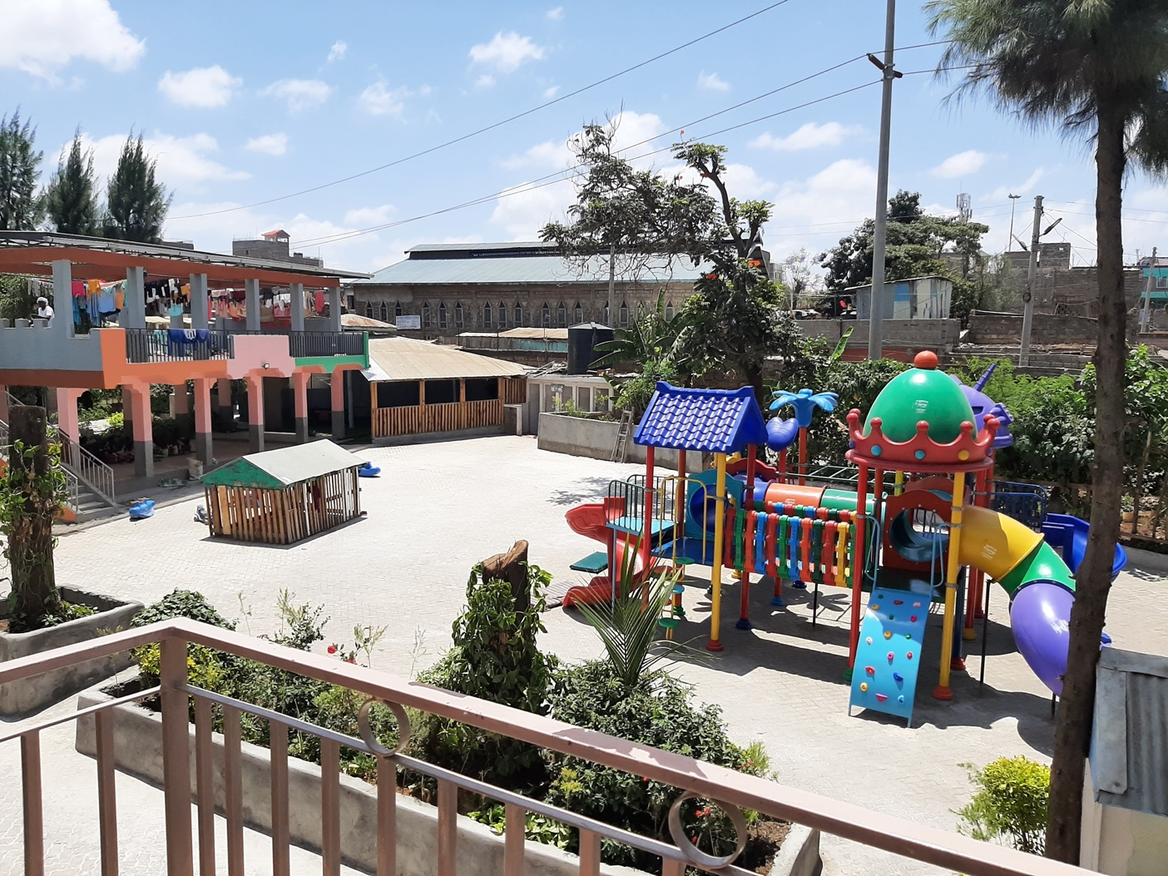

IMANI REHABILITATION AGENCY
P.O BOX 71589-00610
PHONE NO. +254716630900
NAIROBI, KENYA
Contents
2.0 PARENTAL CARE 4
2.1 Admissions 4
2.2 Family reunion 5
2.3 Adoption 5
2.4 Foster Care 6
3.0 EDUCATION 6
3.1 KCPE AND KCSE 7
3.2 School performance 7-8
3.3 Early learning program 8
4.0 HEALTH CARE 9
4.1 Health Insurance 9
4.2 Growth monitoring 9
4.3 Treatments 9
4.4 Clinics 11
4.5 Therapy 11
4.6 Deworming 11
4.7 HIV and AIDS 11
4.8 Children Living with Disabilities 11
4.9 Health talks 11
5.0 CHILD MOTIVATION 12
6.0 ON-GOING PROJECTS 13
7.0 CONCLUSION 16

INTRODUCTION
Its yet another year that we have gone over and accepted its gifts to Imani. The fulfilment of various projects in various place shas been a testimony of resilience and cooperating from all the partners and friends involved in making Imani progress in the right direction.
In this reporting year we have aligned our institutions activities with the government of Kenya care reforms of 2022-2032 where alternative family care has been implemented while foster and adoption programs given priority on children exiting the institution. This has also been in line with our strategic plan of 2020-2025.
In the last two years Imani has been the highest non-governmental institution that has exited most if the children through adoption and foster care programs after the child welfare society of Kenya and this brings us to the close realization of de-institutionalization and puts us in the map for advancing children’s concerns inline with the government’s policies.
Thank you, donors, for your support.
This report highlights in summary the programs and activities Imani undertook in the reporting year.

2.0 PARENTAL CARE.

Parental care is the love, support, guidance, and protection that parents or guardians give to their children to help them grow well.

This is the fundamental program of Imani. All other programs revolve around this core function. At Imani, we ensure that all our centers provide a safe and loving environment for the children, where their rights and dignity are protected.

The table below shows the distribution of the children across the Imani centers.

Branch | Boys | Girls | Overal Total
Babies Unit | 40 | 35 | 75
Imani A | 26 | 35 | 61
Imani B | 31 | 25 | 56
Imani Malindi | 37 | 30 | 67
Imani Ngong | 1 | 0 | 1
Imani Kasarani | 11 | 27 | 38
Foster care | 12 | 19 | 31
Overal Total | 158 | 162 | 320

2.1 Admissions
During the year under review, our home admitted new children in accordance with the established admission policies and procedures. The admissions were conducted following referrals from relevant authorities, including children’s offices, the police, community leaders, and well-wishers.
Each child admitted into the home underwent proper assessment to determine their background, immediate needs, and overall wellbeing. The admission process was guided by the best interest of the child, ensuring their safety, dignity, and protection at all times. Records for all newly admitted children were properly documented and maintained for accountability and follow-up.
Since the beginning of the year, we have admitted 55 new children.

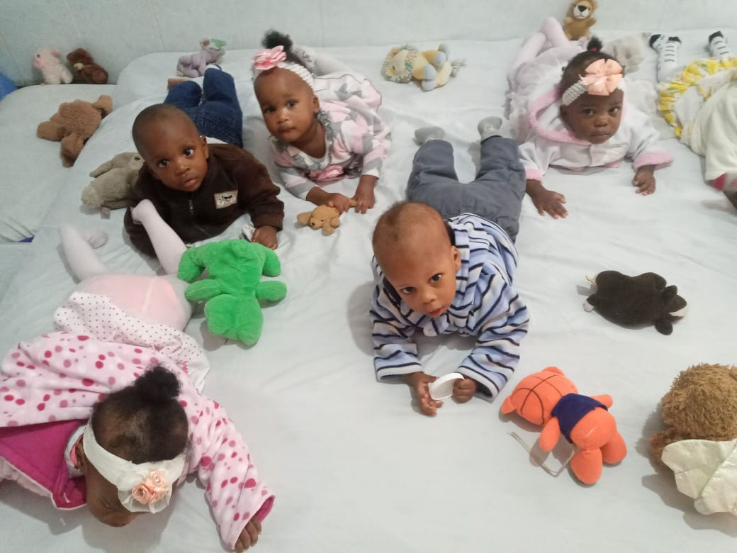
section of the baby house
2.2 Family re-unions
This year, the social work office was able to re- unite 15 children with their families. Re-integration is a continual process and we are still working on exiting more children.

2.3 Adoption
During the year under review, 14 children exited Imani through legal adoption processes. All adoptions were carried out in accordance with the Children Act and under the guidance of relevant government authorities and licensed adoption agencies.
Before placement, each child was carefully assessed to ensure they were legally free for adoption and that the prospective adoptive parents met all required standards. The adoption process prioritized the best interests of the child, ensuring a safe, loving, and permanent family environment. Imani worked closely with children officers, adoption societies, and the judiciary to ensure proper documentation, follow-up, and compliance with all legal requirements. Post-adoption follow-ups were also conducted where applicable to ensure the wellbeing of the children in their new homes.

2.4 Foster Care
Despite the financial constrains in facilitating home tracing, we managed to admit _ children into the foster care system. This is a continual process and much more needs to be done to ensure the foster families have the best intentions of taking good care of the children we put under their care. The social office has been making home visits to the existing foster care homes to see their progress especially during the holidays.
For the current foster care families, we have maintained the following:
- Food basket with the following items: maize flour, wheat flour, sugar, cooking oil and hygienic products e.g. soap, toothpaste, body oil, bathing and washing soaps.
- Assorted clothes and shoes
- School fees, tuition and boarding fees, pocket money and any other amount required by the school like school trips etc.
Medical cover, we make sure all children admitted in Imani are under Social Health fund
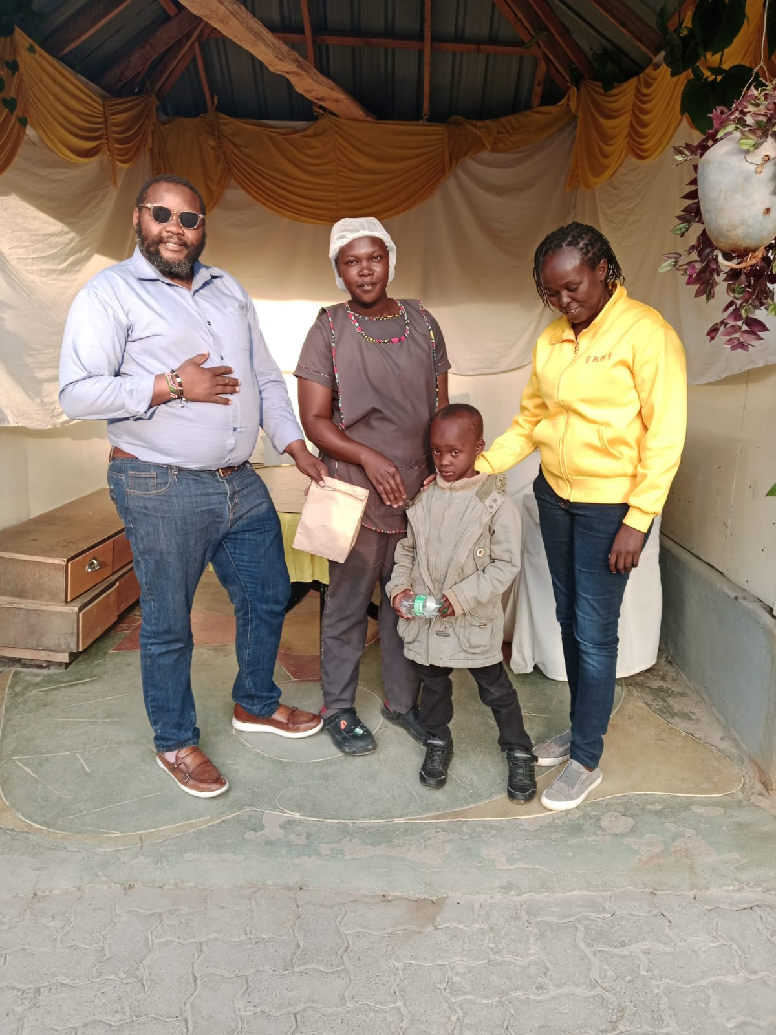
Afamily reunion in one of our centres

3.0 EDUCATION

For more detailed information see the education report 2025

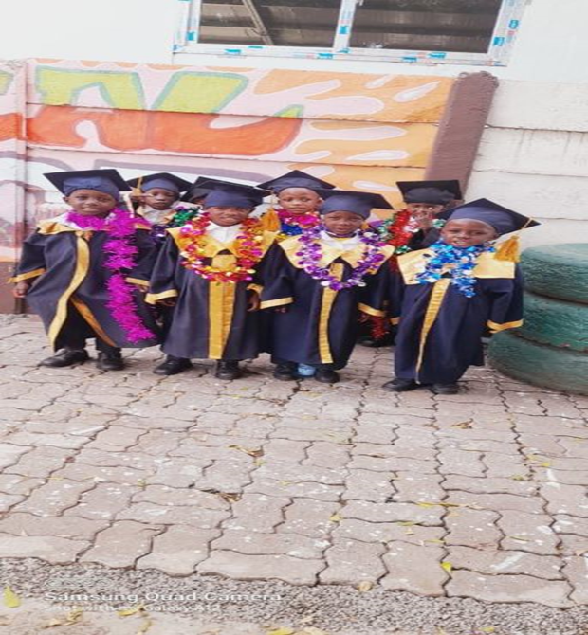
Figure 3: Imani children at their kindergarten graduation
3.1 KJSEA, KPSEA AND KCSE
This year we had three sets of candidates for national exams. The candidates worked hard throughout the year and we trust they attained good results. The table below shows the distribution of the candidates.
 | Boys | Girls | Total
KCSE | 1 | 2 | 3
KPSEA | 6 | 7 | 13
KJSEA | 10 | 6 | 16

3.2 School performance
During the year under review, the children in our care demonstrated steady progress in their academic performance across various schools and learning institutions. Most children attended school regularly and actively participated in both academic and co-curricular activities.
The home continued to support the children by providing school fees, uniforms, learning materials, and a conducive environment for study. Regular follow-ups were conducted with teachers and school administrators to monitor progress and address any learning challenges early.
Several children showed improvement in their grades, particularly in core subjects, while others received additional support through remedial lessons and guidance and counseling. Overall, the academic performance reflected positive growth, discipline, and increased confidence among the children.
3.3 Early learning program
During the year under review, Imani continued to implement an Early Learning Program aimed at supporting the holistic development of young children in our care. The program focused on early childhood education, social development, and foundational life skills to prepare the children for formal schooling. Children enrolled in the program were guided through age-appropriate learning activities that promoted literacy, numeracy, creativity, and motor skills development. The program also emphasized play-based learning, social interaction, and positive behavior formation. The institution provided a safe and supportive learning environment, with trained caregivers and learning materials to enhance the children’s growth and development. Regular assessments were conducted to monitor progress and identify individual learning needs.
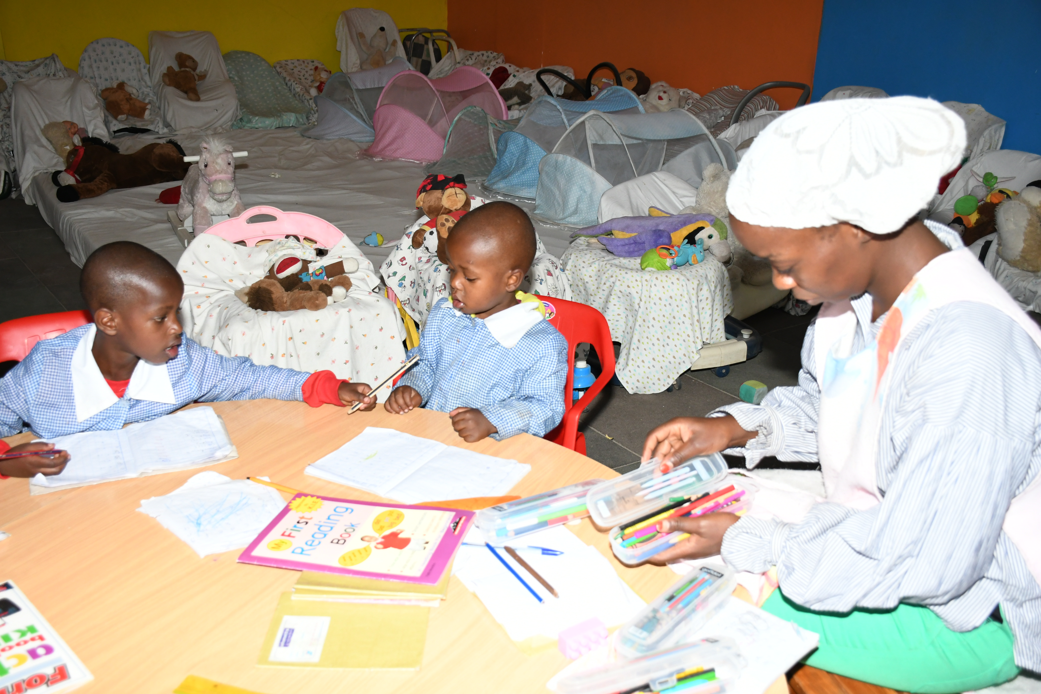
early learning class in session
4.0 HEALTH CARE
Health Care Department at Imani Children’s Home continued to provide essential medical services and support to all children in our care during the year under review. The department is responsible for ensuring that every child maintains good health through regular check-ups, timely treatment, and preventive care.
Medical Services and Support
The department conducted regular health screenings and medical assessments to monitor the children’s growth and wellbeing. Children were taken for routine medical checkups, immunizations, and dental care as required. In cases of illness or emergencies, the department ensured prompt medical attention and proper follow-up until full recovery.
Nutrition and Wellbeing
To promote good health, the Health Care Department worked closely with the kitchen and care staff to ensure a balanced diet and adequate nutrition for all children. Special care was given to children with specific health needs, including those requiring regular medication or dietary adjustments.
Mental Health and Counseling
The department also supported the emotional wellbeing of the children through counseling services and psychosocial support. Children experiencing stress, trauma, or behavioral challenges were given guidance and support to help them cope and grow in a safe environment.
Partnerships and Referrals
The Health Care Department partnered with local hospitals, clinics, and health professionals to access specialized services when needed. Referrals were made for further treatment and specialized care, ensuring that all children received the best possible medical support.
Achievements
- Regular health check-ups were conducted for all children.
- Immunization schedules were updated and followed.
- Prompt treatment and follow-up were provided for all medical cases.
- Mental health support was offered through counseling sessions.

4.1 Health Insurance
Imani Children are registered under the SHA health insurance scheme, ensuring that all Children access quality medical services promptly and without financial strain. The cover for all the children. However, there are still stumbling blocks with the system as it is difficult to access the sha system for newly admitted children especially babies as they lack the basic documents.
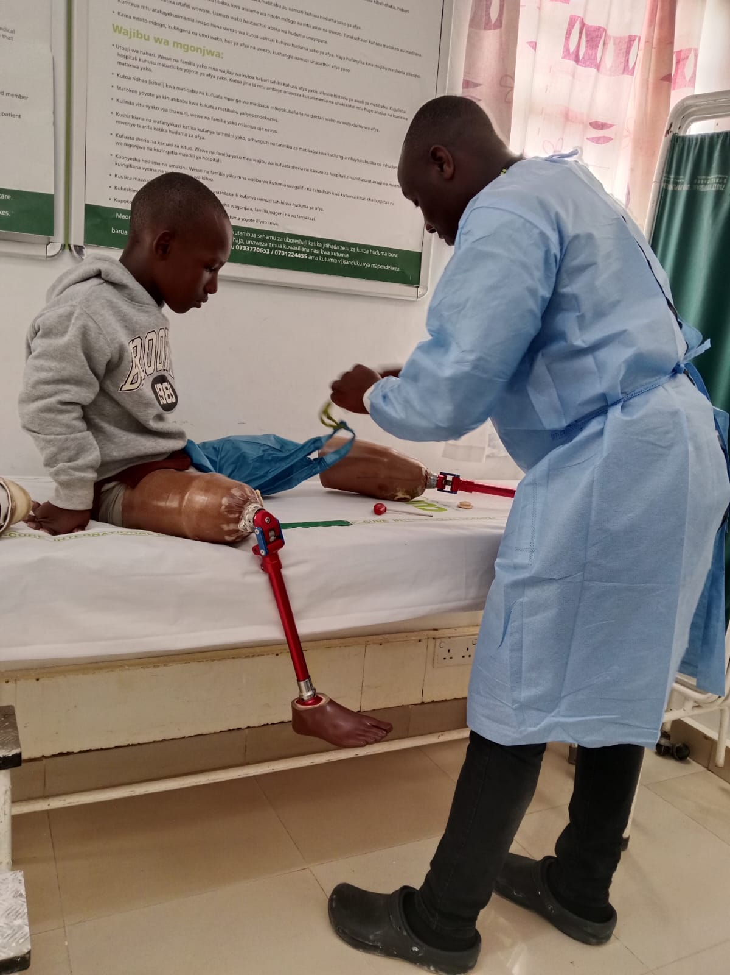
One o the children receiving new prosthetics at Kijabe Cure hospital in Kenya

4.2 Growth monitoring
Growth monitoring is an important health activity conducted regularly at Imani Children’s Home to track the physical development and overall wellbeing of the children. This process helps to identify any signs of malnutrition, illness, or delayed growth early, so that timely action can be taken.
Activities Carried Out
Regular measurement of height and weight
Recording and tracking growth using growth charts
Monitoring nutritional status and overall health
Checking for signs of underweight, stunting, or wasting
Providing timely referrals for medical care when needed
Purpose and Benefits
Growth monitoring helps the Imani to:
Ensure children are growing properly and healthily
Detect health or nutrition problems early
Provide appropriate support and interventions
Improve overall child wellbeing and development
Follow-Up and Support
When a child shows signs of poor growth or malnutrition, the Health Care Department provides extra support such as:
Nutritional counseling
Special diet plans
Medical treatment and follow-up
Regular monitoring until improvement is seen.
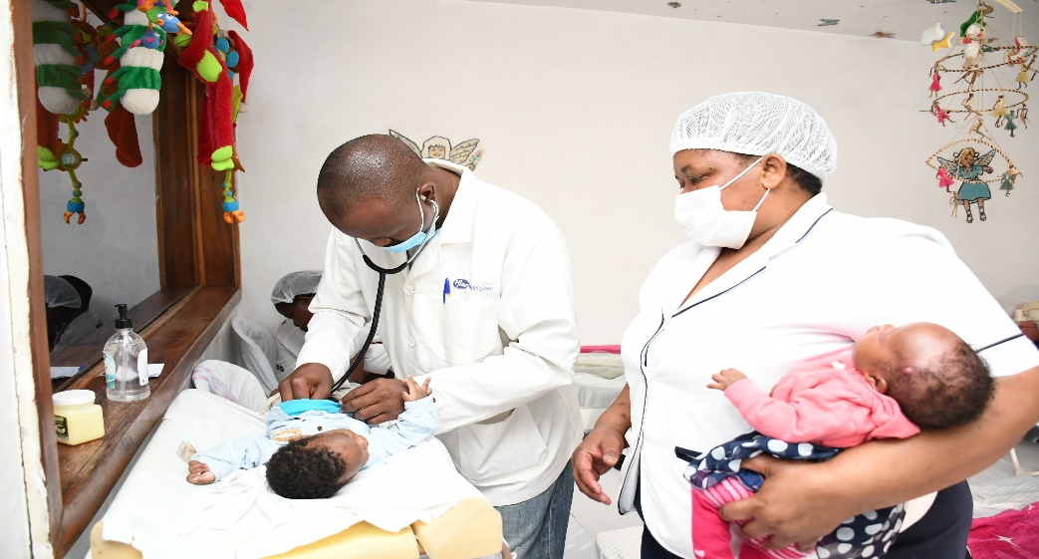
Figure 5: Medical checkup session

4.3 Treatments
The following table shows the different ailments that the children were treated for in the course of the year. During the cold season, the nursing office together with the caregivers worked hard to uphold the children’s good health.
TREATMENT | NUMBER OF CHILDREN
Ear infections | 5
Eye infections | 1
Skin infections | 0
Respiratory infections | 3
pneumonia | 3
Asthma attacks | 4
Allergic bronchitis | 5
Abscess/boils
Allergic reactions | 0
Tonsillitis | 1
Sinuses | 0
Malaria | 0
Diarrhea | 1
Injury/Trauma | 2

4.4 Clinics

27 of our children went for their regular clinic where they got various immunizations. They got following immunizations:
- BCG vaccine – done immediately at birth
- Polio vaccine-within two weeks after birth
- Inactivated Polio vaccine- done at 14 weeks
- Diphtheria/pertussis/tetanus/hepatitis B/Homophiles influenza- done at 6,10 and 14 weeks
- Pneumococcal vaccine- done at 6, 10 and 14 weeks
- Rota virus vaccine – done at 6 and 10 weeks
- Measles Rubella vaccine- 6, 9 and 18 months

4.5 Therapy
Imani Children’s Home provides therapy and rehabilitation services to support children who require extra physical, emotional, or psychological care. These services are designed to help children overcome challenges, improve their wellbeing, and achieve better physical and mental health. Throughout the year, we have had _ children undergo therapy treatment. However, _ of the children are under continual therapy and they are all responding quite well with the help of the caregivers who continue to assist them with the required exercises.

4.6 Deworming
Imani Children’s Home regularly conducts a deworming program to protect children from intestinal worms and improve their overall health. Deworming is an important preventive health activity, especially for children, as worms can cause poor growth, weakness, and poor school performance. Every three months, the children got their deworming treatment. We were able to administer 3 deworming sessions this year.
Activities Conducted
Regular deworming treatment for all children
Coordination with health facilities or health officers for proper medication
Recording and monitoring of treatment dates and follow-up
Education on hygiene to prevent re-infection
Follow-up
After deworming, the Health Care Department monitors the children for any side effects and ensures they remain healthy. Hygiene education is also given to prevent re-infection. This is the general deworming that is administered to all the children even though some children get additional doses as part of their treatment when sick.

4.7 HIV and AIDS

Imani provides support and care for children living with HIV, as well as those affected by HIV and AIDS. Imani is committed to ensuring that every child receives proper medical care, emotional support, and protection from stigma and discrimination.
Medical Care and Treatment
Children living with HIV are supported to access antiretroviral therapy (ART) and regular medical check-ups. The Health Care Department ensures that medication is taken consistently, and that treatment schedules are followed correctly. Regular viral load monitoring and medical follow-ups are conducted to track the health progress of each child.
Nutrition and Wellbeing
The Home provides balanced nutrition and special dietary support where needed to strengthen the immune system and improve overall health. Children living with HIV receive extra attention to ensure they remain healthy and active.
Counseling and Psychosocial Support
Counseling and psychosocial support are provided to help children cope with the emotional and social challenges associated with HIV. The Home encourages a supportive environment where children feel safe, accepted, and respected.
Prevention and Education
The Home conducts health education and awareness sessions on HIV prevention, safe practices, and the importance of testing. Children and staff are taught about HIV transmission, prevention methods, and the importance of regular health checks.
Protection from Stigma
Imani Children’s Home promotes an inclusive and stigma-free environment. Children living with HIV are protected from discrimination and are treated with dignity and respect. Staff members are trained to maintain confidentiality and support each child’s rights. living with HIV and AIDS are responding well to treatments. They have been going for their monthly clinics without fail. The group counseling as well as the individual counseling has been maintained. The children have adhered well to their medications so far and there are no cases of defaulting.

4.8 Children Living with Disabilities
Imani Children’s Home is committed to caring for all children, including those living with disabilities. The Home provides inclusive support to ensure that every child, regardless of ability, receives equal care, education, and opportunities to grow.
Support and Care
Children with disabilities are assessed to determine their specific needs and are provided with appropriate care and support. This includes:
Medical assessments and follow-up care
Physiotherapy or rehabilitation services (where needed)
Assistive devices (e.g., wheelchairs, crutches, hearing aids)
Special attention to nutrition and personal care
Emotional support and counseling
Education and Inclusion
The Home ensures that children with disabilities have access to education through:
Enrollment in inclusive schools
Special needs support where available
Extra tutoring and learning support
Support for mobility and accessibility within the home
Protection and Dignity
The Home promotes a safe and respectful environment where children with disabilities are protected from discrimination, abuse, and neglect. Staff members are trained to treat each child with dignity and to encourage independence and self-esteem.
Achievements
All children with disabilities received consistent care and support
Inclusive education and learning support were provided
The Home strengthened accessibility and safety for children with mobility challenges

4.9 Health talks
The Health Care Department conducted regular health talks to educate children on various health-related topics aimed at promoting healthy living and disease prevention. These talks were designed to increase awareness, encourage positive health behaviors, and improve overall wellbeing.
Topics Covered
Health talks addressed age-appropriate and relevant topics, including:
Personal hygiene and sanitation
Nutrition and healthy eating habits
Prevention of common illnesses
Hand washing and cleanliness
Adolescent health and personal care
Mental health and emotional wellbeing
Implementation
Health talks were conducted through group sessions, interactive discussions, and practical demonstrations. The sessions were facilitated by health staff and, at times, supported by visiting health professionals. Children were encouraged to ask questions and actively participate.
Impact
The health talks helped to improve knowledge, attitudes, and practices related to health among the children. As a result, there was increased awareness of hygiene, better nutrition practices, and improved health-seeking behavior.

5.0 CHILD MOTIVATION
Imani recognizes the importance of motivating children to build confidence, improve behavior, and achieve better results in school and life. The centre has implemented various strategies to encourage and support children in reaching their full potential.

Motivation Activities
The following activities were used to motivate children throughout the year:
Praise and Recognition: Children were praised for good behavior, academic improvement, and positive participation in daily activities.
Rewards and Incentives: Small rewards such as certificates, school supplies, or special treats were given to children who performed well in school or demonstrated positive behavior.
Counseling and Guidance: Children received regular guidance and counseling to help them set goals, build self-esteem, and stay focused on their future.
Mentorship and Role Models: Older children and staff served as role models and mentors to guide younger children and encourage positive habits.
Goal Setting: Children were encouraged to set personal goals in education, behavior, and personal development.
Impact
-These motivational activities helped to:
-Improve children’s confidence and self-esteem
-Encourage better school performance
-Promote discipline and positive behavior
-Build a sense of responsibility and hope for the future
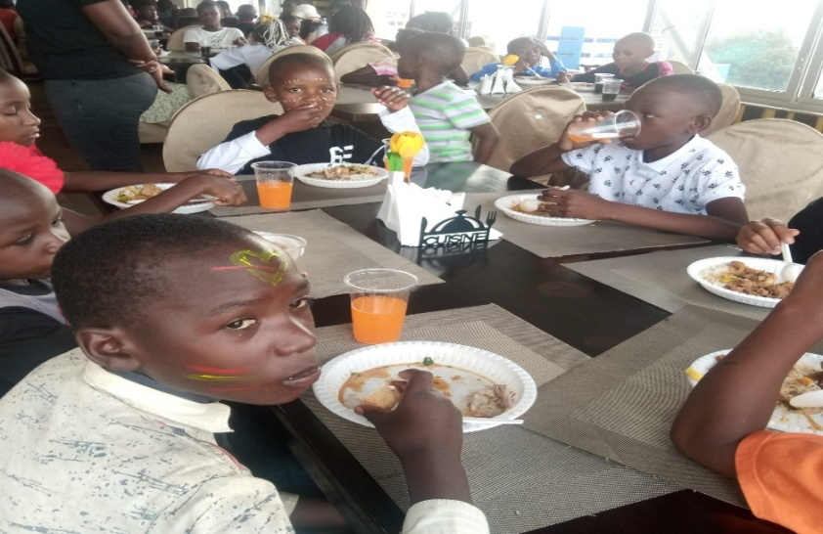
Some of the children during the luncheon at Golden Tulips Hotel

6.0 MAINTENANCE

This reporting year we have had different repairs, replacements and new projects.

New projects: A swimming pool at Imani B donated by the Declan trust, a biogas production plant also donated by the Declan trust and a water heating system at Imani A donated by Majid al-fataim

Replacements: Replacement of Imani Ngong bore hole pump after it broke down. The borehole was also cleaned of silt that was clogging the existing pump and sewer drainage for Imani b restructuring and cleaning parts of the main drainage system at Imani b.

Repairs: General vehicle service for all the Imani vehicles, eneral generator service for Imani generator sets, annual maintenance of computers, printers and scanners in all Imani houses, general plumbing repairs, general electrical repairs and general fabrication repairs.

For more detailed information see the maintenance report.

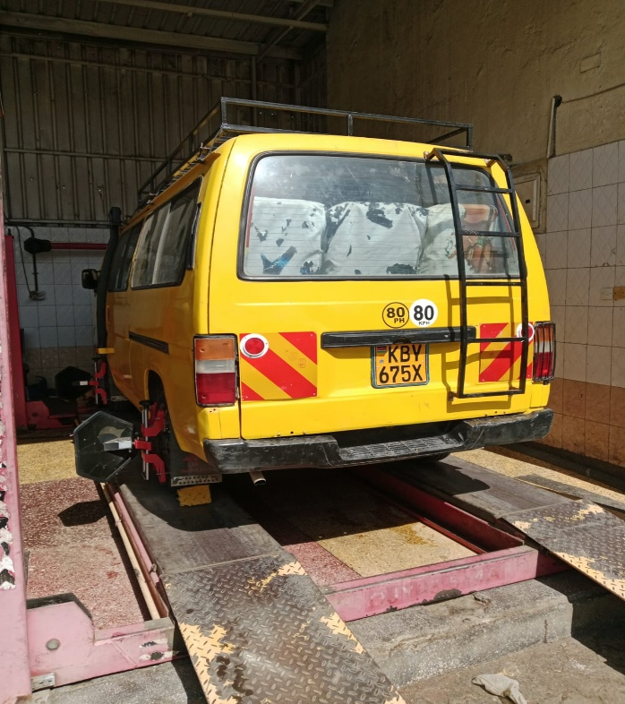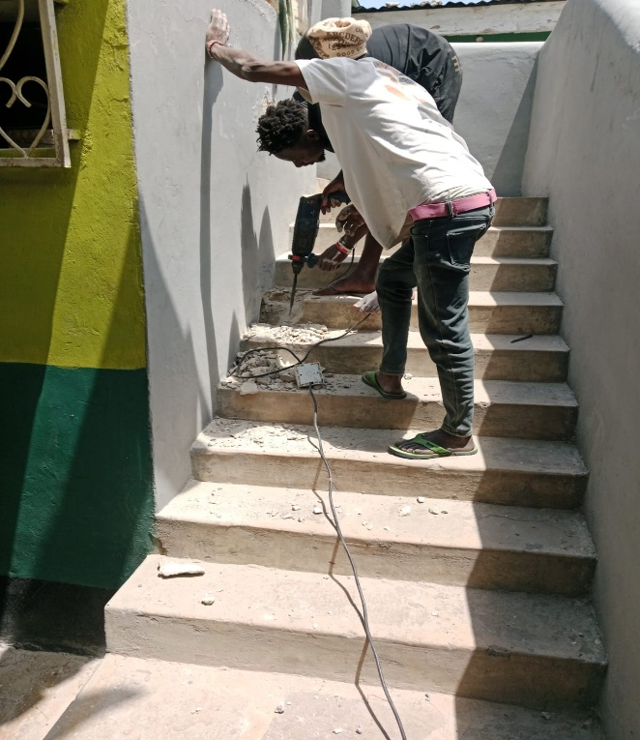
Our van at a service garage General repair works in Imani malindi

7.0 CONCLUSION

In conclusion, the year under review has been a period of growth and progress for Imani Children’s Home. Despite facing various challenges, the Home remained committed to providing a safe, loving, and supportive environment for all children in our care.

Through continued efforts in education, health, and overall child development, the children showed positive improvements in wellbeing, behavior, and academic performance. Imani also strengthened its services in areas such as health care, counseling, inclusive support for children with disabilities, and child protection.

We remain grateful for the support received from our partners, donors, staff, and the community. Their contributions have played a vital role in sustaining the Home’s operations and improving the lives of the children.

Looking ahead, Imani will continue to strive for excellence in care, education, and child development. We will work towards overcoming challenges through improved resource mobilization, enhanced support services, and stronger partnerships to ensure that every child achieves their full potential.

